First Program:

#include<iostream> #include<string.h> using namespace std;

int main(){

char str1[20]="Hello"; char str2[20]="World"; char str3[20];

int len;

//copy first 5 characters of str1 into str3 strncpy(str3, str1, 5);

str3[5] = '\0'; // manually terminate the string to ensure proper behavior cout<<"strncpy( str3, str1, 5) : "<<str3 <<endl;

//concatenate first 5 characters of str1 and str2 strncat(str1, str2, 5);

cout<<"strncat( str1, str2, 5) : "<<str1 <<endl;

//tatal length of str1 after concatenation len = strlen(str1);

cout<<"strlen(str1) : "<<len <<endl; return 0;

}

**OutPut:**

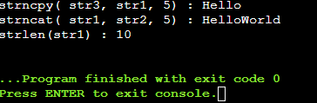

**Program2:**

#include<iostream> #include<string.h> using namespace std;

int main(){

char str1[20]="Hello"; char str2[20]="World"; char str3[40];

int len;

//copy first 5 characters of str1 into str3 strncpy(str3, str1, 5);

str3[5] = '\0'; // manually terminate the string to ensure proper behavior cout<<"str3 : "<<str3<<endl;

//concatenate str1 and str2 strcat(str3, str2);

cout<<" str1 + str2 : "<<str3 <<endl;

//tatal length of str3 after concatenation len = strlen(str3);

cout<<"strlen(str3) : "<<len<<endl;

return 0;

}